Implementation of a Cybersecurity Network Intrusion Detection Pattern Visualization Dashboard
A CAPSTONE PROJECT REPORT
Submitted in the partial fulfilment for the Course of
DHV – Data Handling and Visualization
to the award of the degree of
BACHELOR OF ENGINEERING
IN
ARTIFICIAL INTELLIGENCE AND DATA SCIENCES
Submitted by
JAANA NITHISH(192324275)
AKASH S(192324298)
SURYA J K(192324285)
Under the Supervision of
Dr. S. Senthilvadivu

SIMATS ENGINEERING
Saveetha Institute of Medical and Technical Sciences
Chennai-602105
August 2026

 | SIMATS ENGINEERING  Saveetha Institute of Medical and Technical Sciences  Chennai-602105 | 
DECLARATION
We, JAANA NTIHISH (192324275AKASH S(192324298),and SURYA J K(192324285)of the BTech Artificial Intelligence and Data Sciences, Saveetha Institute of Medical and Technical Sciences, Saveetha University, Chennai, hereby declare that the Capstone Project Work entitled ‘Implementation of a Cybersecurity Network Intrusion Detection Pattern Visualization Dashboard’
is the result of our own bonafide efforts. To the best of our knowledge, the work presented herein is original, accurate, and has been carried out in accordance with principles of engineering ethics.
Place: Chennai
Date:
Signature of the Students with Names
JAANA NITHISH (192324275)
AKASH S(192324298)
SURYA J K(192324285)
 | SIMATS ENGINEERING  Saveetha Institute of Medical and Technical Sciences  Chennai-602105 | 
BONAFIDE CERTIFICATE
This is to certify that the Capstone Project entitled “Implementation of a Cybersecurity Network Intrusion Detection Pattern Visualization Dashboard” has been carried out by JAANA NITHISH (192324275),AKASH S(192324298),and SURYA J K(192324285)under the supervision of Dr. S. Senthilvadivu and is submitted in partial fulfilment of the requirements for the current semester of the BTech program Artificial Intelligence and Data Sciences at Saveetha Institute of Medical and Technical Sciences, Chennai.
SIGNATURE SIGNATURE
Dr. Anusuya S Dr. S. Senthilvadivu
Program Director Professor
Department of CSE Department of CSE
Saveetha School of Engineering Saveetha School of Engineering
SIMATS SIMATS
Submitted for the Project work Viva-Voce held on ___________________________.
INTERNAL EXAMINER EXTERNAL EXAMINER

ACKNOWLEDGEMENT
We would like to express our heartfelt gratitude to all those who supported and guided us throughout the successful completion of our Capstone Project. We are deeply thankful to our respected Founder and Chancellor, Dr. N.M. Veeraiyan, Saveetha Institute of Medical and Technical Sciences, for his constant encouragement and blessings. We also express our sincere thanks to our Pro-Chancellor, Dr. Deepak Nallaswamy Veeraiyan, and our Vice-Chancellor, Dr. S. Suresh Kumar, for their visionary leadership and moral support during the course of this project.
We are truly grateful to our Director, Dr. Ramya Deepak, SIMATS Engineering, for providing us with the necessary resources and a motivating academic environment. Our special thanks to our Principal, Dr. B. Ramesh, for granting us access to the institute’s facilities and encouraging us throughout the process. We sincerely thank our Head of the Department, Dr. Anusuya S, for continuous support, valuable guidance, and constant motivation.
We are especially indebted to our guide Dr. S. Senthilvadivu for creative suggestions, consistent feedback, and unwavering support during each stage of the project. We also express our gratitude to the Project Coordinators, Review Panel Members, and the entire faculty team for their constructive feedback and valuable inputs that helped improve the quality of the project. Finally, we thank all faculty members, lab technicians, our parents, and friends for their continuous encouragement and support.
Signature with Student Name
JAANA NITHISH(192324275)
AKASH S(192324298)
SURYA J K(192324285)
ABSTRACT
Podcast platforms generate large amounts of listening and audience-interaction data. Understanding which podcast categories, episodes, and content characteristics attract listeners can be difficult when the information is stored as separate records. This project proposes a Podcast Listening Trend and Audience Engagement Visualization System that converts podcast listening data into meaningful visual insights.
The system combines listening trends and engagement indicators into a single visualization-oriented interface. Listening Trend Analysis focuses on plays, listening duration, completion rate, episode popularity, category trends, and time-based changes. Audience Engagement Analysis focuses on likes, comments, shares, ratings, followers, and engagement rate. The data is cleaned, transformed, and organized into dashboard-ready metrics, allowing patterns and changes to be observed easily.
The proposed system demonstrates the use of line charts, bar charts, pie charts, KPI cards, ranking views, and category comparisons. Illustrative data may be used to demonstrate the dashboard design without claiming that the values represent a commercial podcast platform. The system provides a structured foundation for understanding audience behavior and can later be extended with recommendation analytics, audience segmentation, anomaly detection, prediction of episode performance, and real-time monitoring.
Keywords: podcast, listening trends, audience engagement, visualization, dashboard, plays, completion rate, ratings, comments, shares, data analytics

TABLE OF CONTENTS
S.No. | Contents | Page
1 | Abstract | 5
2 | Chapter 1: Introduction | 7
2.1 | Background Information | 7
2.2 | Project Objectives | 7
2.3 | Significance | 8
2.4 | Scope | 8
2.5 | Methodology Overview | 9
3 | Chapter 2: Problem Identification and Analysis | 10
3.1 | Description of the Problem | 10
3.2 | Evidence of the Problem | 10
3.3 | Stakeholders | 11
3.4 | Supporting Data / Research | 11
3.5 | Performance Variables and Dashboard Model | 12
3.6 | Assumptions | 12
3.7 | Constraints | 12
3.8 | Need for Visualization-Based Monitoring | 13
4 | Chapter 3: Solution Design and Implementation | 14
4.1 | Development and Design Process | 14
4.2 | Tools and Technologies Used | 14
4.3 | Solution Overview | 15
4.4 | Listening Trend Analysis Module | 15
4.5 | Audience Engagement Visualization Module | 16
4.6 | Dashboard Architecture | 16
4.7 | Worked Visualization Example | 17
4.8 | Evaluation Metrics | 17
4.9 | Solution Justification | 18
5 | Chapter 4: Results and Recommendations | 19
5.1 | Evaluation of Results | 19
5.2 | Listening Trend Analysis | 19
5.3 | Audience Engagement Analysis | 20
5.4 | Challenges Encountered | 20
5.5 | Possible Improvements | 20
5.6 | Recommendations and Limitations | 21
6 | Chapter 5: Reflection on Learning and Personal Development | 22
6.1 | Key Learning Outcomes | 22
6.2 | Challenges Encountered and Overcome | 22
6.3 | Application of Data Visualization Practices | 23
6.4 | Insights into the Industry | 23
6.5 | Conclusion of Personal Development | 23
7 | Chapter 6: Conclusion | 24
8 | References | 25
9 | Appendices | 26

CHAPTER 1: INTRODUCTION
1.1 Background Information
Network intrusion detection is the process of monitoring network traffic to identify unauthorized access, misuse, or malicious activity directed at computer systems. As organizations scale their digital infrastructure, network devices generate continuous streams of connection records — each capturing details such as source and destination IP addresses, ports, protocols, packet sizes, connection duration, and flags indicating how a session terminated. On their own, these records are just rows of numeric and categorical values with no immediate meaning to a human analyst.
An Intrusion Detection System (IDS) analyzes this traffic and classifies connections as normal or malicious, often further categorizing attacks into types such as Denial of Service (DoS), Probing/Port Scanning, Brute Force, Botnet activity, and Web-based attacks. The growth of network traffic volume creates a practical data-handling challenge: a Security Operations Center (SOC) analyst cannot manually inspect thousands of connection logs generated every minute. A visualization system is therefore useful for converting raw, high-volume alert and traffic data into a structured, interpretable view that highlights patterns, spikes, and anomalies without requiring the analyst to read every individual record.
1.2 Project Objectives
- Design a dashboard-oriented system for monitoring network intrusion patterns and traffic behavior.
- Visualize connection volume, protocol distribution, packet/byte statistics, and traffic trends over time.
- Visualize attack-type frequency, severity distribution, alert counts, and blocked-vs-allowed activity.
- Compare attack categories and source IP behavior using suitable visualizations.
- Identify relationships between traffic volume spikes and rising attack activity.
- Provide KPI cards and filters for rapid interpretation of network security posture.
- Create a scalable foundation for future anomaly detection, prediction, and real-time monitoring.
1.3 Significance
The project connects data handling and visualization principles with a practical cybersecurity problem. Raw network logs are useful for storage and forensic review, but visual analytics make attack patterns easier to interpret quickly — which matters in security monitoring, where response time affects impact. A coordinated dashboard can help an analyst understand not just how much traffic occurred, but what kind of traffic it was and how threatening it was.
The system is significant because traffic volume and threat severity describe different dimensions of network behavior. Connection count represents load, packet/byte volume represents data movement, attack-type frequency represents the nature of the threat, and severity/alert level represents urgency. Examining these variables together prevents misleading conclusions drawn from a single metric — for example, a spike in connections is not automatically an attack, and a low-volume attack (like a slow brute-force attempt) is not automatically harmless just because its traffic volume is small.
For example, a network segment can show a large number of connections because of a legitimate traffic surge (such as a product launch), while a separate, much smaller stream of connections from a single source IP repeatedly probing closed ports is a Probe/Scan attack. A visualization system can reveal this difference and support faster, better-informed security decisions.
1.4 Scope
The scope of the project covers the preparation and visualization of network intrusion/traffic data. The system includes time-based trend analysis, attack-type ranking, protocol/category comparison, KPI summaries, severity indicators, source-IP analysis, and a conceptual dashboard architecture. Data can be stored in CSV or JSON form (e.g., derived from datasets such as NSL-KDD or CICIDS2017-style records) and transformed into a structured analytical dataset.
The project does not attempt to build a live packet-capture engine, a production-grade IDS/IPS, or an automated response/blocking system. Real-time packet sniffing, signature-database maintenance, deep packet inspection, and active network defense are outside the present scope. These areas may be considered as future extensions.
1.5 Methodology Overview
The methodology begins by identifying the variables required to describe network traffic and intrusion activity. Data is then collected or defined in time-indexed connection records. Cleaning removes invalid records, standardizes protocol/attack-type labels, and handles missing values. Derived measures such as attack rate and block rate are calculated. Finally, visual components are selected according to the nature of each metric.
Stage | Activity | Output
1 | Identify network/security metrics | Metric set
2 | Collect or define connection records | Structured dataset
3 | Clean and transform | Dashboard-ready data
4 | Analyze traffic trends | Trend views
5 | Analyze attack/threat patterns | Threat views
6 | Interpret results | Insights and recommendations
1.5 Methodology Overview — Detailed Process
The first stage defines a consistent vocabulary for the dataset. Each observation should identify the connection/session ID, source IP, destination IP, protocol, service/port, timestamp, packet count, byte count, connection duration, and attack label. Consistent definitions matter because comparisons become unreliable if one record classifies an attack type differently from another.
The second stage focuses on data preparation. Duplicate connection records are identified, missing values are reviewed, numerical fields are converted into consistent types, and attack-category names are standardized (e.g., grouping variants of DoS attacks under one label). Time fields are converted into a common format so that hourly, daily, or weekly trends can be calculated.
The third stage derives analytical indicators. Attack rate can be represented as the proportion of connections classified as malicious. Block rate can measure the proportion of malicious connections that were successfully flagged/blocked. Average packet size and connection duration can be compared across attack types to provide additional context.
Visualization Principles Applied
- Use line charts for ordered time-based traffic and attack-frequency trends.
- Use bar charts for ranking attack types or comparing source IPs.
- Use KPI cards for current totals, averages, and headline security indicators.
- Use composition (pie/donut) charts only when attack categories represent meaningful parts of one total.
- Use consistent units and labels so metrics are not misinterpreted.
- Provide filters for date, protocol, attack type, and severity when the dataset is large.
- Keep explanatory text close to complex metrics so the dashboard remains understandable to non-technical stakeholders.
Expected Outcome
The expected outcome is a structured visualization system that allows a security analyst to move from a high-level summary to detailed trends and comparisons. The design should reduce the effort required to interpret raw connection logs and provide a clear basis for discussing network security posture.

CHAPTER 2: PROBLEM IDENTIFICATION AND ANALYSIS
2.1 Description of the Problem
The central problem is the difficulty of interpreting network security posture when traffic and attack information is stored as separate, high-volume raw values. A connection count shows load but not intent. An attack label shows classification but not how the threat evolved over time. A blocked-count shows defensive action but may not reflect how severe the underlying attack actually was. Without a combined visual view, important relationships can remain hidden.
The problem becomes more difficult as the volume of logged connections grows. Manual review of raw logs can require repeated filtering, sorting, and cross-referencing — a process that does not scale and delays response to active threats. It is also easy to overlook gradual changes, such as a slow-building reconnaissance (probing) phase that precedes a larger attack. Visualization provides a way to make these patterns visible before they escalate.
2.2 Evidence of the Problem
Time-indexed network traffic can change significantly between periods. A coordinated attack can produce a sharp spike in connection attempts from a small set of source IPs, followed by a rapid drop once the attack concludes or is blocked. A Probe/Scan phase may show a gradual increase in connections to varied ports from one source, distinct from the sudden burst pattern typical of a DoS attack. Seasonal or operational events (e.g., a new service deployment) may also affect legitimate traffic volume, making it harder to distinguish threat activity from normal load changes.
Severity adds another layer. Some attack types generate a high volume of low-severity alerts (such as repeated failed logins), while others produce fewer but critical-severity alerts (such as a successful privilege escalation). A high connection count together with low severity indicates a different risk profile than a low connection count with high severity. A useful dashboard should retain the time dimension and show multiple related indicators together.
2.3 Stakeholders
Stakeholder | Primary Need | Useful Dashboard View
Security Analyst | Detect and triage active threats | Real-time attack trend and severity view
SOC Manager | Understand overall network security posture | KPI summary and category comparison
Network Administrator | Identify traffic anomalies affecting infrastructure | Traffic volume and protocol trends
Incident Response Team | Investigate and respond to specific attacks | Filtered source-IP and time-series drill-down
Data Analyst | Study historical attack behavior | Filtered time-series dataset
Developer | Maintain the analytics/dashboard system | Clear metric definitions and architecture
2.4 Supporting Data / Research
Network intrusion analytics can be organized around two broad families: traffic measures and threat measures. Traffic measures describe the volume and nature of network activity — how much data moved, through which protocols, and for how long. Threat measures describe how that activity was classified and how severely it should concern an analyst. The proposed system intentionally keeps these families connected because neither family alone gives a complete picture of network security.
Important traffic variables include connection count, packet count, byte count (source/destination), connection duration, protocol type, and service/port. Important threat variables include attack type/category, severity level, alert count, source-IP reputation, and a block/allow outcome flag.
2.5 Performance Variables and Dashboard Model
Variable | Meaning | Unit / Form
Connection Count | Number of recorded network connections | count
Packet Count | Number of packets transmitted per connection | count
Byte Count | Data volume transmitted | bytes/KB
Connection Duration | Time span of a session | seconds
Attack Type | Classification of the connection | category (DoS, Probe, Brute Force, Botnet, Web Attack, Normal)
Severity Level | Risk rating of the alert | Low / Medium / High / Critical
Alert Count | Number of alerts raised | count
Blocked Connections | Connections denied by defense mechanism | count
Attack Rate | Share of connections classified malicious | %
Block Rate | Share of malicious connections blocked | %
2.6 Assumptions
- Records are time-stamped and can be ordered chronologically.
- The meaning of each attack-type label is consistent across the dataset.
- Illustrative/sample values are identified clearly when live network telemetry is unavailable.
- Severity and attack-rate formulas are documented and applied consistently.
- The logging frequency is sufficient to reveal meaningful attack patterns.
- Source-IP and protocol identifiers remain stable during analysis.
2.7 Constraints
The dashboard depends on the quality of the source data. Missing connection records or incomplete labels can produce misleading trends — a gap in logging may look like a drop in attack activity even when the real cause is a data-collection failure. The system therefore needs validation rules and visible indicators for incomplete records.
Another constraint is metric and label definition. Different intrusion datasets or sensors may define an "attack," a "connection," or a "severity level" differently. A dashboard can calculate a value correctly while still producing an invalid comparison if the underlying label definitions are inconsistent across data sources. The report therefore treats metric and category definitions as part of the analytical model.
2.8 Need for Visualization-Based Monitoring
Visualization is needed because network threat activity is dynamic and multi-dimensional. A single average (e.g., total connections per day) cannot explain the complete security posture of a network. Coordinated charts can show whether a rise in connections is accompanied by a rise in attack rate, whether a particular attack type is trending upward, and whether one source or protocol consistently generates more threats than others.
Problem-to-Solution Mapping
Observed Problem | Visualization Response | Expected Benefit
Too many raw connection logs | KPI summary | Fast overview
Unclear changes over time | Line chart | Trend visibility
Hard to compare attack types | Ranking bar chart | Quick comparison
Severity differences hidden | Severity distribution chart | Pattern recognition
Volume confused with threat level | Combined KPIs | Balanced interpretation
Important attack windows overlooked | Date filters | Focused analysis
Manual repeated calculations | Derived metrics | Consistent reporting
Analytical Questions
- Which attack types occur most frequently?
- Which source IPs generate the highest volume of malicious connections?
- Which time periods show the sharpest rise in attack activity?
- Does higher traffic volume coincide with higher attack rate?
- How does severity distribution change across attack categories?
- Which protocols are most frequently targeted?
Data Quality and Preparation Requirements
Data preparation is critical because visualization quality depends on the reliability of the underlying dataset. A preparation workflow should inspect duplicate connection records, missing timestamps, invalid negative byte/packet counts, inconsistent attack-type labels, and incompatible units. Records that cannot be trusted should be removed or flagged rather than silently included.
Temporal aggregation must also be handled carefully. Per-second or per-minute values can contain short bursts of noise, while hourly or daily aggregation can reveal broader attack campaigns. The dashboard should allow the analyst to select a suitable period when the dataset supports it.
Derived Metrics
Derived Metric | Example Definition | Use
Attack Rate | Malicious connections / total connections × 100 | Threat prevalence
Block Rate | Blocked connections / malicious connections × 100 | Defense effectiveness
Average Packet Size | Total bytes / total packets | Traffic profiling
Alert Growth | Ending alert count − beginning alert count | Escalation tracking
Severity Rate | High/Critical alerts / total alerts × 100 | Risk concentration
Status Classification
A simple status layer can classify network segments or time windows as Healthy, Watch, or Attention based on configurable thresholds (e.g., attack rate above a set percentage). Such labels should not be treated as universal truths — they are useful only when thresholds are chosen from historical baseline behavior or clearly defined project rules. The purpose is to direct analyst attention, not to replace security judgment.

CHAPTER 3: SOLUTION DESIGN AND IMPLEMENTATION
3.1 Development and Design Process
The proposed system follows a pipeline architecture consisting of data acquisition, preprocessing, metric calculation, visualization, and interpretation. The pipeline separates data handling from presentation so that metric definitions remain stable even if the dashboard interface changes.
During acquisition, records may originate from CSV/JSON exports of network logs, a public intrusion-detection dataset (e.g., NSL-KDD or CICIDS2017-style records), or a simulated log source. During preprocessing, fields are validated and standardized. During metric calculation, derived indicators (attack rate, block rate, severity rate) are generated. The visualization layer then maps each metric to an appropriate chart or KPI component. The interpretation layer supports filtering and comparison.
3.2 Tools and Technologies Used
Tool / Concept | Purpose in Project
Python | General data processing and analysis
Pandas / NumPy | Cleaning, transformation, grouping, and aggregation
Matplotlib / Plotly | Charts for trends and comparisons
Streamlit | Interactive dashboard presentation and filtering
CSV / JSON | Portable dataset storage
Time-Series Model | Organization of timestamped connection/alert records
Microsoft Word | Technical report preparation
3.3 Solution Overview
The system is divided into two main analytical modules. The first module, Intrusion Trend Analysis, focuses on network traffic and attack-volume behavior. The second module, Threat & Alert Pattern Visualization, focuses on severity and response behavior. A common filtering layer connects both modules so that the same time range, protocol, or attack type can be examined from both perspectives.
3.4 Intrusion Trend Analysis Module
The Intrusion Trend Analysis module provides a high-level view of how network traffic behaves over time. KPI cards can display total connections, total attack count, average attack rate, and the number of active source IPs. Trend charts can show how connection volume and attack frequency change by hour, day, or week.
Attack-type ranking is useful when the analyst needs to identify the most active threats quickly. A bar chart can rank attack types by frequency, average duration, or byte volume. A protocol comparison can show which services attract more malicious traffic. These views should use the same filters so rankings can be interpreted within a selected period.
Key Traffic/Trend Views
- Total connections KPI and trend.
- Attack-rate trend over time.
- Connection-duration distribution by attack type.
- Top attack types ranked by frequency.
- Top source IPs ranked by malicious-connection count.
- Protocol-level traffic comparison.
- Attack-window analysis showing spikes during specific periods.
Interpretation Example
Suppose Attack Type A generates more total connections than Attack Type B, but Attack Type B has a substantially higher average severity. The dashboard should not label Attack Type A automatically as the greater threat. Instead, it should show that Attack Type A has higher volume while Attack Type B demonstrates higher risk per incident. This distinction is one of the main reasons for using multiple coordinated visualizations rather than a single ranking.
3.5 Threat & Alert Pattern Visualization Module
The Threat & Alert module focuses on how the system classifies and responds to detected activity. Alert counts, severity levels, and blocked/allowed outcomes can be shown as headline KPIs and trends. Because raw alert counts are influenced by overall traffic volume, normalized indicators such as attack rate and block rate can be used as supporting measures.
Threat analysis should remain connected to traffic behavior. A high number of alerts with low severity may indicate broad, low-risk noise (e.g., automated scanning bots), while a low alert count with high severity may indicate a smaller number of serious, targeted attempts. These interpretations require context rather than a single universal rule.
Key Threat/Alert Views
- Alert count and severity trend over time.
- Attack-type distribution (pie/bar) by category.
- Average severity by attack type.
- Blocked vs. allowed connections over time.
- Block-rate trend.
- Top source IPs by alert count.
- Comparison of volume, severity, and block-rate together.
Filter and Interaction Design
A practical dashboard can provide filters for date range, attack type, protocol, severity level, and source IP. When the dataset is sufficiently detailed, additional filters may include destination port or geographic origin. Filters should update related KPIs and charts together so the analyst does not accidentally compare values from different populations.
Design Principle
The interface should make the most important question visible first: is the network under attack right now? Detailed diagnostic charts can then answer what kind of attack and how severe. This layered structure prevents the dashboard from becoming crowded while retaining analytical depth.
3.6 Dashboard Architecture
Layer | Function | Output
Data Source | Receive traffic and alert records | Raw logs
Processing | Validate, clean, standardize | Clean dataset
Analytics | Aggregate and derive metrics | Analytical indicators
Visualization | Render KPIs and charts | Dashboard views
Interaction | Filter, compare, inspect | Focused analysis
Interpretation | Summarize findings | Insights / actions
The architecture is designed so each layer has a defined responsibility. The data source does not determine visual presentation. Processing does not contain dashboard-specific formatting. Analytics contains formulas and aggregation rules, while visualization decides how those results are displayed. This separation makes the system easier to maintain.
3.7 Worked Visualization Example
Consider a network segment that experiences a sudden spike in connection attempts from a single source IP across many destination ports in a short time window. This pattern is characteristic of a Port Scan/Probe attack. A coordinated dashboard would allow the analyst to see that connection volume rose sharply while severity remained low initially — then observe whether a follow-up spike in a different attack category (e.g., Brute Force) occurred shortly after, suggesting the scan was reconnaissance for a targeted attack.
A second example involves a smaller volume of connections but a high proportion classified as Critical severity — such as repeated failed authentication attempts against an administrative account. The category should not be dismissed simply because its total volume is low; the severity-weighted view reveals a targeted, high-risk attempt requiring immediate attention.
3.8 Evaluation Metrics
Metric | Purpose | Preferred Interpretation
Total Connections | Measure traffic volume | Higher indicates greater network load
Attack Rate | Measure threat prevalence | Higher indicates a greater share of malicious traffic
Block Rate | Measure defense effectiveness | Higher indicates stronger mitigation
Average Severity | Measure risk concentration | Higher indicates more serious incidents
Alert Growth | Measure escalation | Positive growth indicates rising threat activity
Top Attack Type Share | Measure category dominance | Higher share indicates a concentrated threat pattern
3.9 Solution Justification
The proposed solution is appropriate because it combines complementary measurements rather than relying on a single score. KPI cards provide a rapid summary, time-series charts expose change, ranking views support comparison, and severity indicators provide risk context. The system therefore supports both continuous monitoring and deeper incident analysis.
Implementation Logic
- Load records from the selected data source.
- Validate schema, timestamps, IP/port fields, and numerical values.
- Standardize attack-type and protocol labels.
- Calculate attack-rate, block-rate, and severity-based indicators.
- Aggregate values by selected time interval.
- Apply user-selected filters.
- Render KPI cards and charts.
- Provide explanatory labels and status indicators.
- Refresh results when filters or time ranges change.
This logic can be implemented initially as an offline analytical dashboard using sample/illustrative datasets and later connected to a live network monitoring feed. The same metric definitions should be retained when moving from sample data to production telemetry so comparisons remain meaningful.

CHAPTER 4: RESULTS AND RECOMMENDATIONS
4.1 Evaluation of Results
The proposed dashboard design provides a coordinated view of network traffic and threat activity. The expected result is that analysts can identify major security events without reading every underlying log entry. Traffic KPIs provide load and volume context, while threat KPIs provide risk and response context.
Dashboard Area | Expected Result | Assessment
Traffic KPI Cards | Headline values visible | Clear
Intrusion Trend | Time-based changes visible | Clear
Attack-Type Ranking | Most active threats identifiable | Clear
Severity View | Risk differences visible | Clear
Alert KPIs | Threat activity summarized | Clear
Protocol Comparison | Targeted services visible | Clear
Block-Rate Trend | Defense effectiveness visible | Clear
Filters | Focused analysis by date/type/severity | Recommended
4.2 Intrusion Trend Analysis
The intrusion trend view demonstrates why time order should be preserved. A total connection count can show overall load, but a trend can reveal the timing of an attack's onset, peak, and decline. When time markers are shown alongside trends, the analyst can also examine whether spikes coincide with known events (deployments, public holidays, or previous incident windows).
4.3 Threat & Alert Pattern Analysis
Threat analysis adds context to traffic activity. High connection volume with low attack rate may indicate broad but benign load, while lower volume with high attack rate may indicate a smaller, more concentrated threat. The dashboard should present these patterns without automatically declaring one pattern more dangerous than the other — context and severity matter more than volume alone.
4.4 Challenges Encountered
- Selecting enough metrics to explain security posture without causing visual overload.
- Maintaining consistent definitions for attack type, severity, and connection.
- Choosing appropriate aggregation periods for trend analysis.
- Separating traffic volume from actual threat severity.
- Handling missing, duplicate, or inconsistent log records.
- Keeping ranking and comparison charts readable as attack categories grow.
- Defining thresholds without treating illustrative rules as universal security benchmarks.
4.5 Possible Improvements
- Add interactive filters for protocol, attack type, severity, and date.
- Introduce source-IP reputation scoring based on historical behavior.
- Add anomaly detection for unusual spikes in connections or alerts.
- Use predictive models to forecast likely attack windows.
- Add automated alert-correlation to link related events into a single incident.
- Add campaign annotations to mark known attack periods.
- Connect the dashboard to real-time network telemetry and alerting.
- Add drill-down views from protocol to attack type to individual connection.
4.6 Recommendations and Limitations
The main screen should prioritize a small set of high-value KPIs and provide detailed charts through secondary views. Metric and label definitions should be documented beside the dashboard or in an information panel. Thresholds should be validated against real historical traffic data before being used for automated alerts.
The current project is a visualization-oriented design and may use illustrative or publicly available sample datasets (such as NSL-KDD-style records). It does not establish live production security benchmarks or claim measured protection for a real organizational network. Real deployment would require live packet capture, signature/anomaly detection engines, privacy and compliance controls, and validation against actual attack outcomes.

CHAPTER 5: REFLECTION ON LEARNING AND PERSONAL DEVELOPMENT
5.1 Key Learning Outcomes
The project strengthened understanding of data preparation, time-series analysis, metric definition, dashboard planning, and visualization selection — applied specifically to cybersecurity data. It demonstrated that a security dashboard is not simply a collection of alerts on a screen; each visual should answer a specific analytical question and use a representation suited to the data type.
Working with network intrusion data also highlighted the importance of separating raw traffic measurements from derived risk indicators. A rate or percentage (like attack rate) can be useful, but analysts must know its numerator, denominator, and time window. This improved understanding of analytical transparency and reproducibility in a security context.
5.2 Challenges Encountered and Overcome
One challenge was deciding which security variables were essential. Including every available log field could make the dashboard difficult to read. The solution was to separate headline KPIs (attack rate, block rate, total alerts) from diagnostic details (individual connection records). Another challenge was comparing attack types with very different natural frequencies — normalized measures such as severity rate were considered alongside absolute counts.
A further challenge involved maintaining consistent time scales, since traffic and alert events can occur at very different frequencies (per-second connections vs. per-incident alerts). This process improved understanding of how data preparation influences visualization quality in high-volume, time-sensitive domains.
5.3 Application of Data Visualization Practices
- Line charts were selected for ordered time-series traffic and attack trends.
- Bar charts were selected for attack-type and source-IP comparisons.
- Pie/donut charts were used for attack-category composition where appropriate.
- KPI cards were selected for headline security measures.
- Labels and units were kept explicit throughout.
- Illustrative/sample values were distinguished from real production telemetry.
- Filters were considered to reduce information overload during incident triage.
- Multiple related indicators were coordinated to support interpretation.
5.4 Insights into the Industry
Cybersecurity operations depend heavily on data analytics to detect and respond to threats at scale. A modern network can generate millions of connection records per day, and attack behavior varies significantly across time, protocol, and threat actor. Analytics systems help transform this raw activity into information that SOC teams and organizations can act on quickly.
The project also illustrates the role of data visualization in security communication. An analyst may understand raw log files, but a dashboard can make the same information accessible to a wider group of stakeholders — management, incident response, and compliance teams can use a shared visual language when discussing network security posture.
5.5 Conclusion of Personal Development
Overall, the project improved analytical thinking, data organization, chart selection, dashboard planning, technical writing, and interpretation of time-dependent security data. It also reinforced the importance of asking what decision a visualization is intended to support — detection, triage, or reporting — before selecting a chart type.
Practical Skills Developed
- Data cleaning and structured dataset preparation for security logs.
- Time-series aggregation and attack-trend interpretation.
- Definition and calculation of security analytical metrics.
- Selection of charts appropriate for categorical and time-based threat data.
- Dashboard information hierarchy and layout planning.
- Communication of security findings in report form.
- Recognition of limitations in illustrative/sample intrusion datasets.
Future Learning Direction
Future work can extend these skills into interactive dashboard development, live packet-capture integration, API-based log ingestion, machine-learning-based anomaly detection, and responsible security-data management. These extensions would build on the same foundation of clear metric definitions and appropriate visualization.
Data Visualization as a Decision-Support Practice
The project demonstrated that effective visualization is closely related to security decision-making. An analyst may want to know which attack to triage first, which protocol needs hardening, or whether a recent policy change reduced attack rate. Each question requires a different view of the data, and a general dashboard becomes more useful when its components are connected to explicit security questions.
The project also reinforced the importance of context. A connection count that appears high in isolation may be normal for a particular time of day or service. Comparisons should therefore use consistent time periods and baselines, and rate-based metrics should complement absolute counts.
Responsible Interpretation
Security analytics should not be interpreted as definitive proof of compromise without supporting evidence. A high attack-rate reading can have many possible causes (including false positives from an overly sensitive detection rule), and a quiet period does not guarantee the absence of a sophisticated, low-and-slow attack. The visualization system should present evidence and trends while leaving final incident conclusions to further investigation by a qualified analyst.
Personal Development Summary
The work developed a stronger understanding of the complete path from raw network data to visual security insight: define the question, identify variables, prepare data, calculate metrics, select a visual representation, evaluate the result, and communicate the finding. This workflow is applicable beyond intrusion detection and provides a foundation for future data-driven security projects.

CHAPTER 6: CONCLUSION
This project proposed a Cybersecurity Network Intrusion Detection Pattern Visualization Dashboard for analyzing network security posture through coordinated data visualization. The design combines traffic indicators such as connection count, packet/byte volume, and connection duration with threat indicators including attack type, severity level, alert count, and block rate.
The system is organized into two major analytical modules. Intrusion Trend Analysis focuses on how network traffic behaves over time, while Threat & Alert Pattern Visualization focuses on how that activity is classified and responded to. Common filters and a shared analytical structure allow users to compare these dimensions within the same protocol, attack type, or time period.
The proposed architecture separates data acquisition, preprocessing, analytics, visualization, and user interaction. This separation supports maintainability and makes it possible to replace illustrative/sample data with real network telemetry in a future implementation. The architecture can also be extended without redesigning the basic metric model.
The project demonstrates that visualization can communicate security patterns more effectively than isolated raw values. A trend can reveal the rise or fall of an attack campaign, a ranking can identify the most active threats, and a combined view can show differences between traffic volume, severity, and defensive response. These perspectives support more informed network security analysis.
Future extensions may include anomaly detection, predictive attack modeling, source-IP reputation scoring, real-time dashboards, incident-correlation views, and automated alerting. Such extensions should be validated with real network data and should preserve transparency about how metrics and attack labels are defined.
In conclusion, the proposed system provides a structured and understandable approach to handling and visualizing network intrusion data. By combining traffic and threat perspectives, it can support clearer reporting, faster incident triage, and future security-monitoring decisions while recognizing the limitations of illustrative datasets.

REFERENCES
- McKinney, W. (2022). Python for Data Analysis (3rd ed.). O'Reilly Media.
- Matplotlib Development Team. (2024). Matplotlib documentation: Visualization with Python.
- Pandas Development Team. (2024). Pandas user guide: Data analysis and time-series processing.
- Knaflic, C. N. (2015). Storytelling with Data: A Data Visualization Guide for Business Professionals. Wiley.
- Munzner, T. (2014). Visualization Analysis and Design. CRC Press.
- Kleppmann, M. (2017). Designing Data-Intensive Applications. O'Reilly Media.
- Tavallaee, M., Bagheri, E., Lu, W., & Ghorbani, A. A. (2009). A Detailed Analysis of the KDD CUP 99 Data Set. IEEE Symposium on Computational Intelligence for Security and Defense Applications.
- Sharafaldin, I., Lashkari, A. H., & Ghorbani, A. A. (2018). Toward Generating a New Intrusion Detection Dataset and Intrusion Traffic Characterization (CICIDS2017). ICISSP.
- Few, S. (2013). Information Dashboard Design: Displaying Data for At-a-Glance Monitoring. Analytics Press.
- Tufte, E. R. (2001). The Visual Display of Quantitative Information. Graphics Press.
- Streamlit Documentation — https://streamlit.io/
- Plotly Documentation — https://plotly.com/python/
- Canadian Institute for Cybersecurity — NSL-KDD Dataset — https://www.unb.ca/cic/datasets/nsl.html
Note: The references above provide methodological and visualization background. The present project report does not claim that illustrative values represent measurements from a live production network.

APPENDICES
Appendix A: Sample Dashboard KPI Record

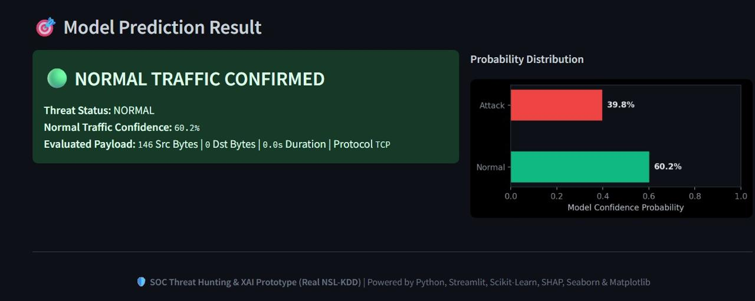

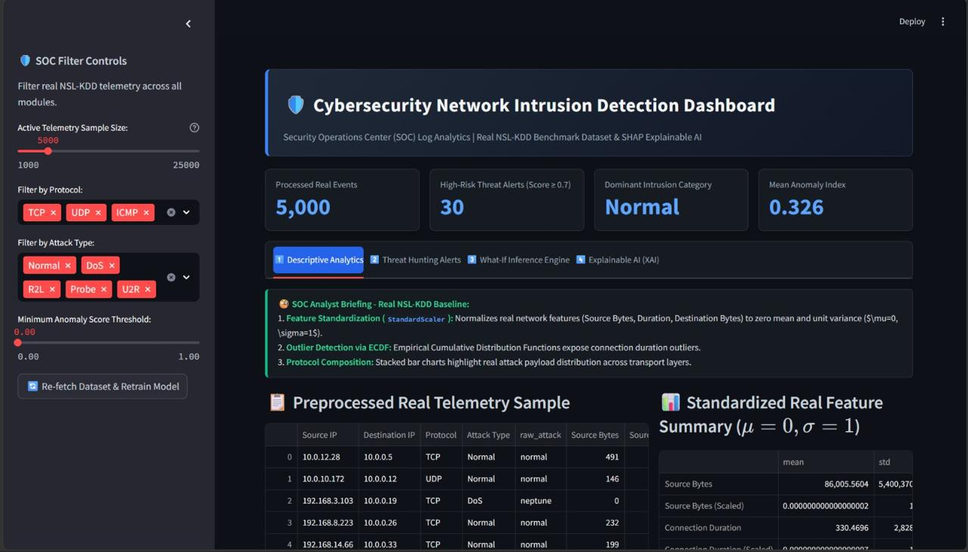
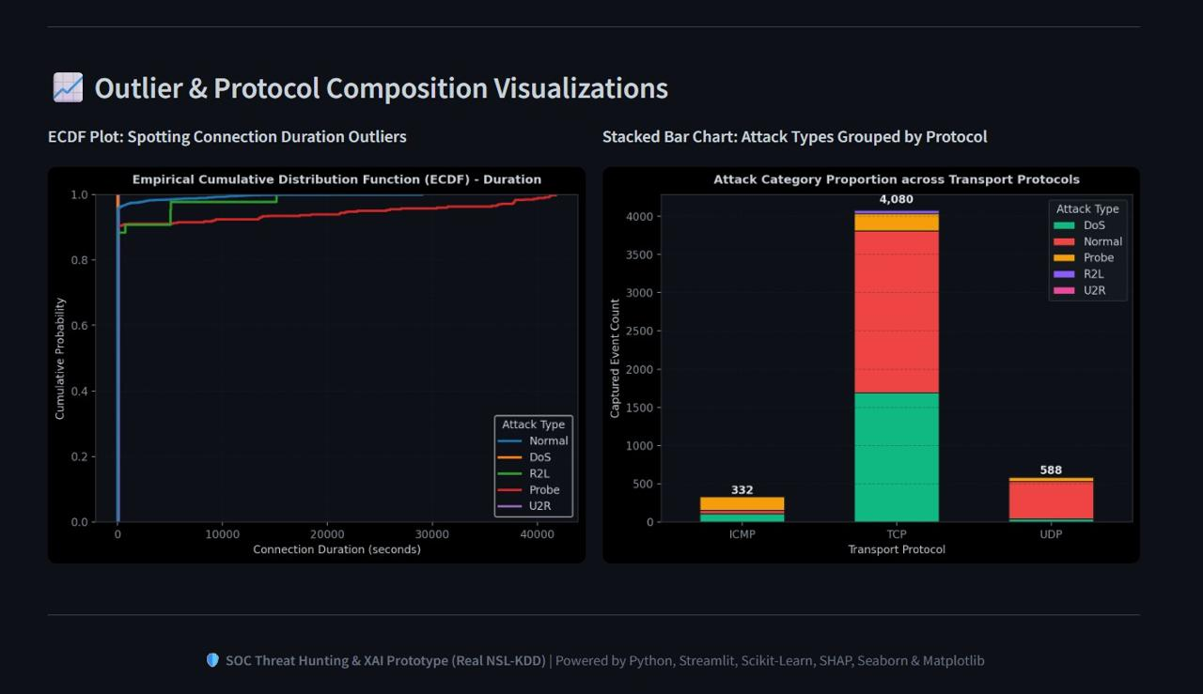

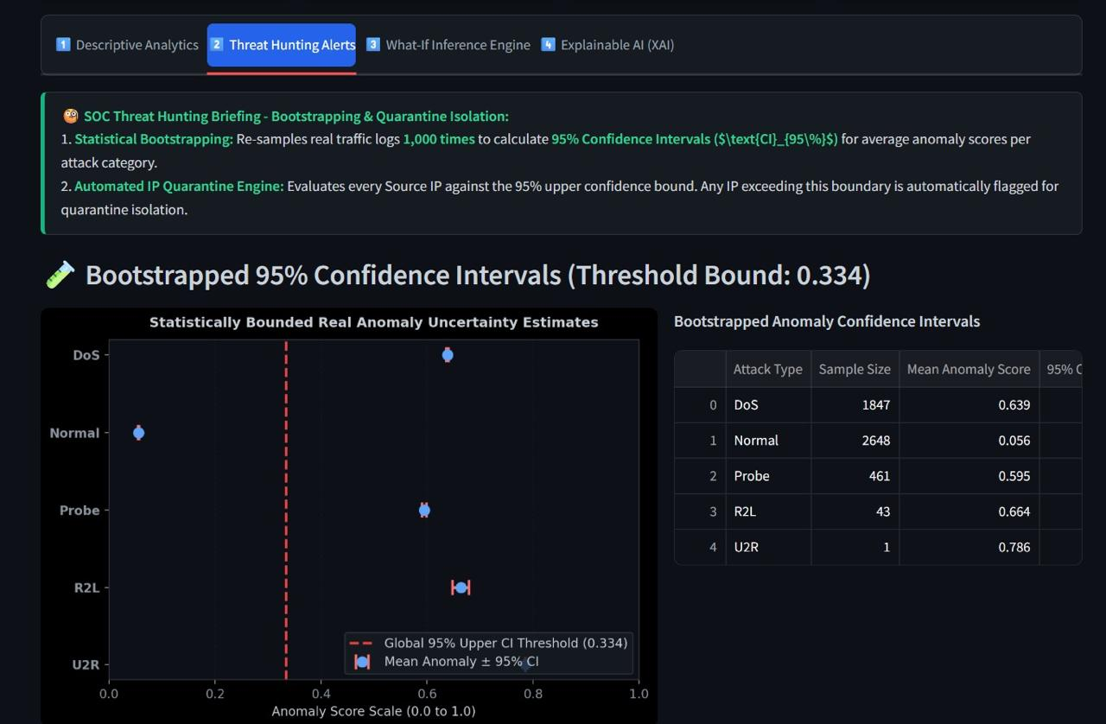
Period | Connections | Attack Count | Attack Rate | Blocked | Block Rate | Status
Hour 1 | 4,820 | 210 | 4.4% | 195 | 92.9% | Healthy
Hour 2 | 5,140 | 340 | 6.6% | 300 | 88.2% | Watch
Hour 3 | 6,760 | 610 | 9.0% | 520 | 85.2% | Watch
Hour 4 | 7,920 | 980 | 12.4% | 790 | 80.6% | Attention
Hour 5 | 6,510 | 430 | 6.6% | 400 | 93.0% | Healthy
Appendix B: Dashboard Data-Processing Pseudocode
- Read time-stamped network connection and alert records.
- Validate timestamps and remove invalid or duplicate records.
- Standardize protocol, port, and attack-type identifiers.
- Calculate attack rate, block rate, and severity rate.
- Group records by selected period and analytical dimension.
- Render KPI cards, trend charts, rankings, and category comparisons.
- Refresh dashboard views after filter changes.
- Flag missing or threshold-sensitive observations.
Appendix C: Validation Checklist
Check | Expected Condition | Result
Timestamp order | Records appear chronologically | Pass
Missing values | Handled or flagged | Pass
Duplicate records | Removed or reviewed | Pass
Units | Consistent units | Pass
Attack-type labels | Standardized | Pass
Trend charts | Time order preserved | Pass
Attack-type rankings | Correct sorting applied | Pass
Severity metrics | Configured formula applied | Pass
Illustrative data | Clearly identified | Pass

